IWACA 2016 Alex Doyle 2015713

WIREFRAMES

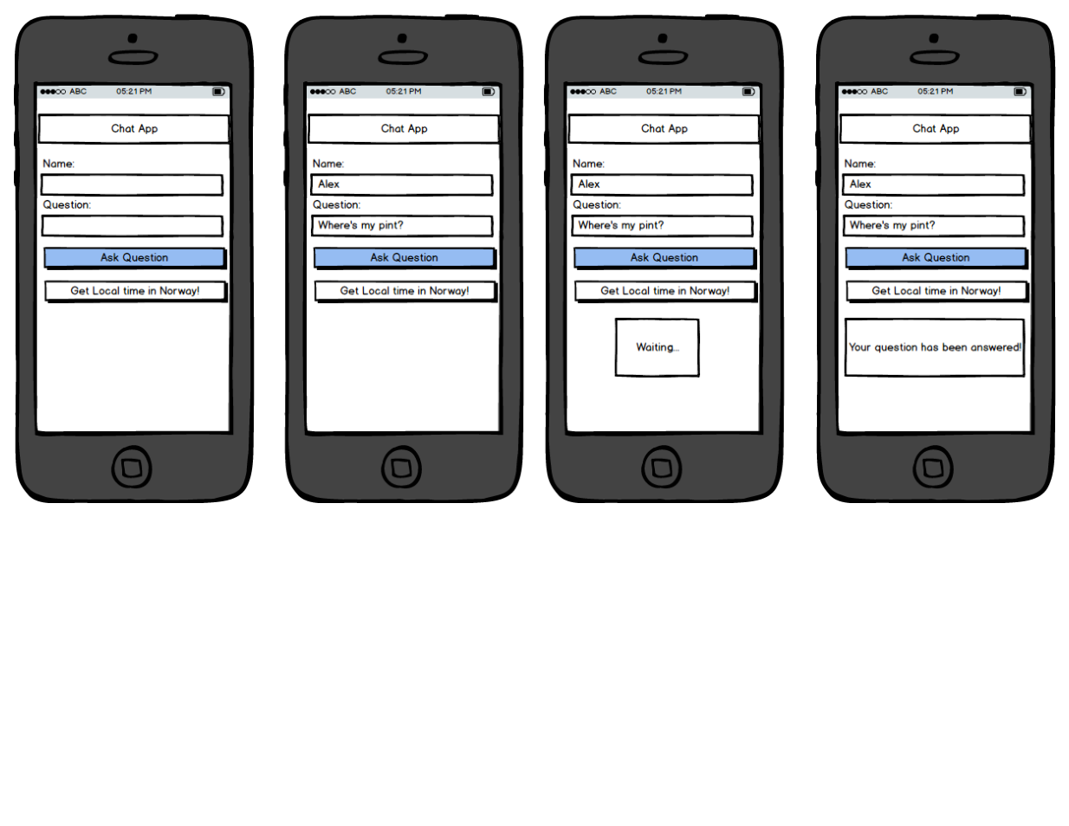

(used Balsamiq)

SIKULI

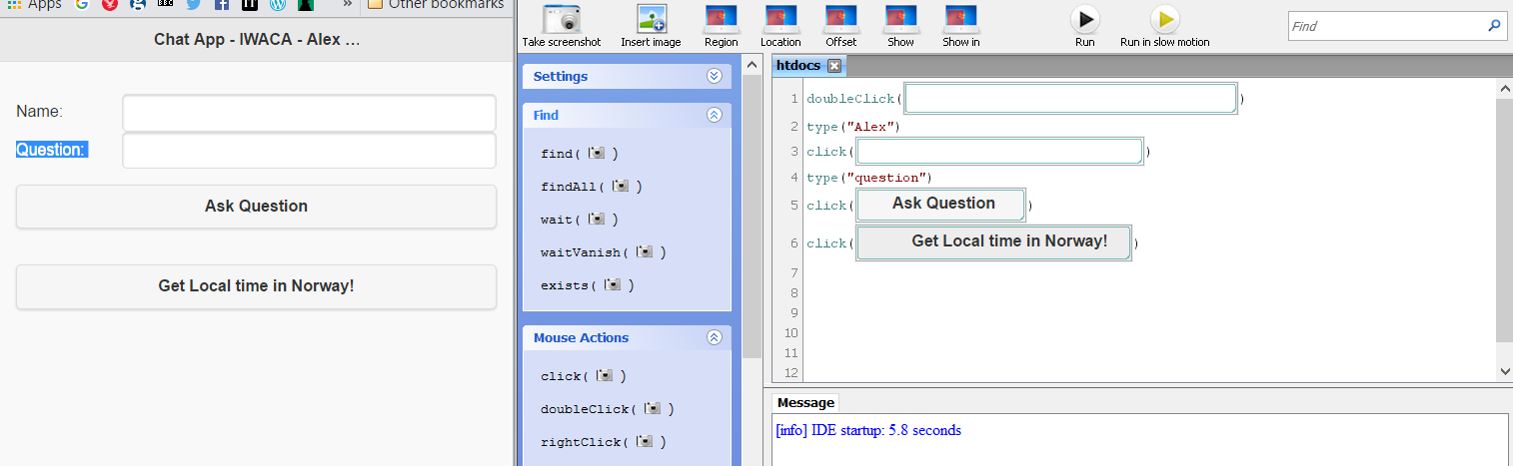

GITHUB

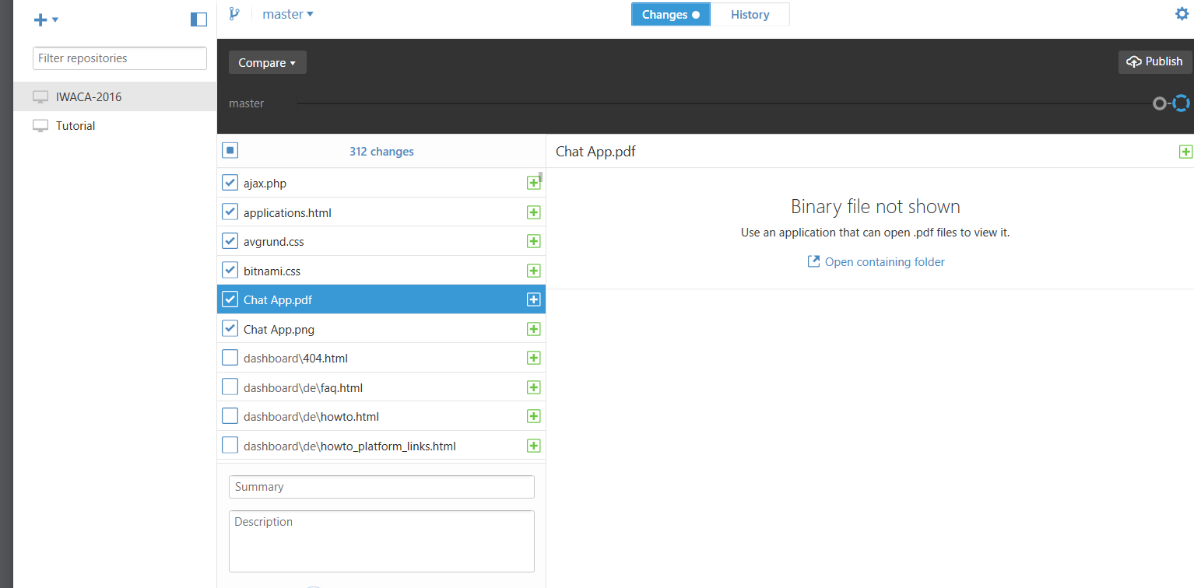

(used the Desktop version)